**Lớp 2- bài 5- ôn tập**

**UNIT 5: WHERE ARE THE BALLS?**

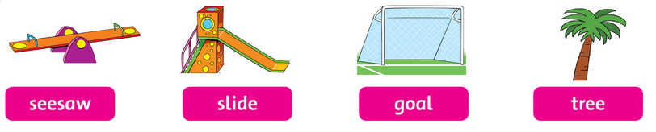

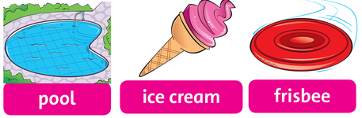

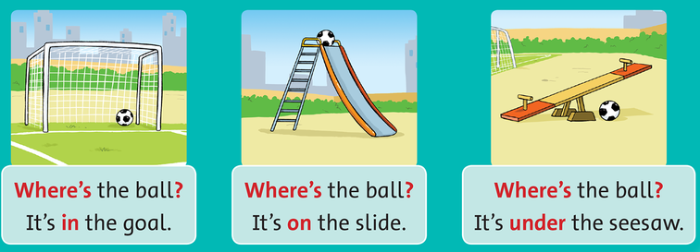

1. **Write the words**

seesaw…………………………………………………………………………………………………………………………………………………………………………………………………………...........

slide………………………………………………………………………………………………………………………………………………………………………………………………………………………….

goal…………………………………………………………………………………………………………………………………………………………………………………………………………………………

tree………………………………………………………………………………………………………………………………………………………………………………………………………………………….

pool………………………………………………………………………………………………………………………………………………………………………………………………………………………..

ice cream………………………………………………………………………………………………

………………………………………………………………………………………………………………

frisbee……………………………………………………………………………………………………………………………………………………………………………………………………………………

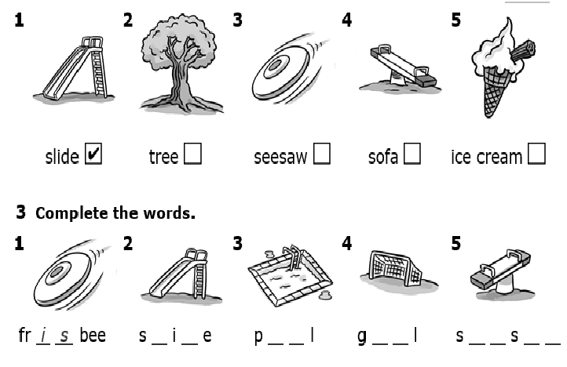

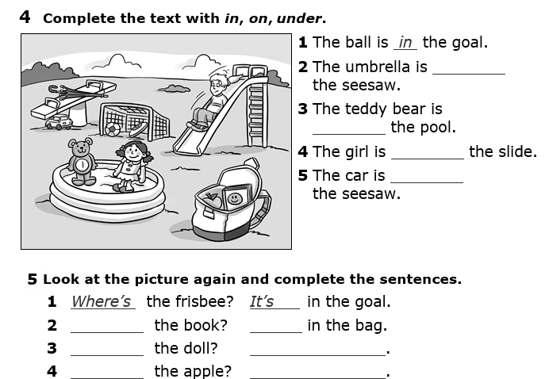

**Đáp án (unit 5 ôn tập)**

**Bài 2**

2)✓ 3) 🗶 4) 🗶 5)✓

**Bài 3**

2) slide 3) pool 4) goal 5) seesaw

**Bài 4**

2) on 3) in 4) on 5) under

**Bài 5**

2) Where - It’s

3) Where’s – It’s in the pool.

4) Where’s – It’s in the bag.